Sophie’s Story
Sophie is a 14 year old high school student who was referred to Alliance Physical Therapy with a one year history of gradually worsening neck pain and headaches that radiated from the base of her skull to the front of her head. She arrived at the initial evaluation with her mother and recounted how they had spent the last 12 months seeing multiple specialists including Neurologists and undergoing a seemingly endless barrage of tests from an MRI to EEG/EKG all without any clear answer. Sophie felt the pain had initially started gradually without any specific injury and just gotten worse.
As a highly competitive gymnast who had aspirations of competing at the State Championship, the last 12 months had been very rough for Sophie. She had tried to continue through the pain and headaches as much as she could but by the time she came to Alliance PT her headaches were constant and it was affecting her concentration and school work.
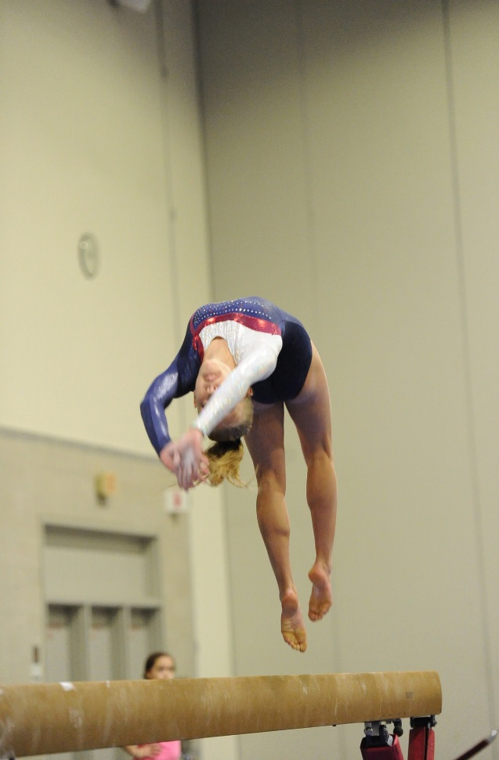
During the evaluation Phil was struck by the sight of a 14 year old girl who could barely turn her head 25% of the normal range. When asked to look up as high as she could, Sophie could only tilt the chin slightly and look up with her eyes. All of these movements caused significant increase in Sophie’s neck pain. The degree of muscle spasm and stiffness in the neck joints was so astounding for such a healthy young lady. Following an in-depth physical therapy evaluation, Phil felt certain he could help her.
Phil recalls, “The hardest thing was going to be getting her to stop doing gymnastics long enough to actually allow the treatment to take effect.” After much discussion Sophie bravely agreed to a plan to take a break. This break would leave her with only one chance to qualify for the state championship.
By the 4th visit of PT she was already reporting dramatic improvement. Her year-long headache had gone, her neck pain was down from 8/10 to 3/10 on the pain scale and her neck ROM was nearly 75% of normal. This improvement was also reflected in her FOTO score which increased 15 points.
Sophie would go on to have 10 visits of PT in 6 weeks and was discharged with full neck ROM and no pain or headaches. On her final appointment she scored herself 96% on the FOTO questionnaire, a full 39 point increase from the first visit.
In the weeks since that appointment her mom called to share the news that Sophie had placed first in the final qualifying meet, following that up with second place in State Championship Meet!

